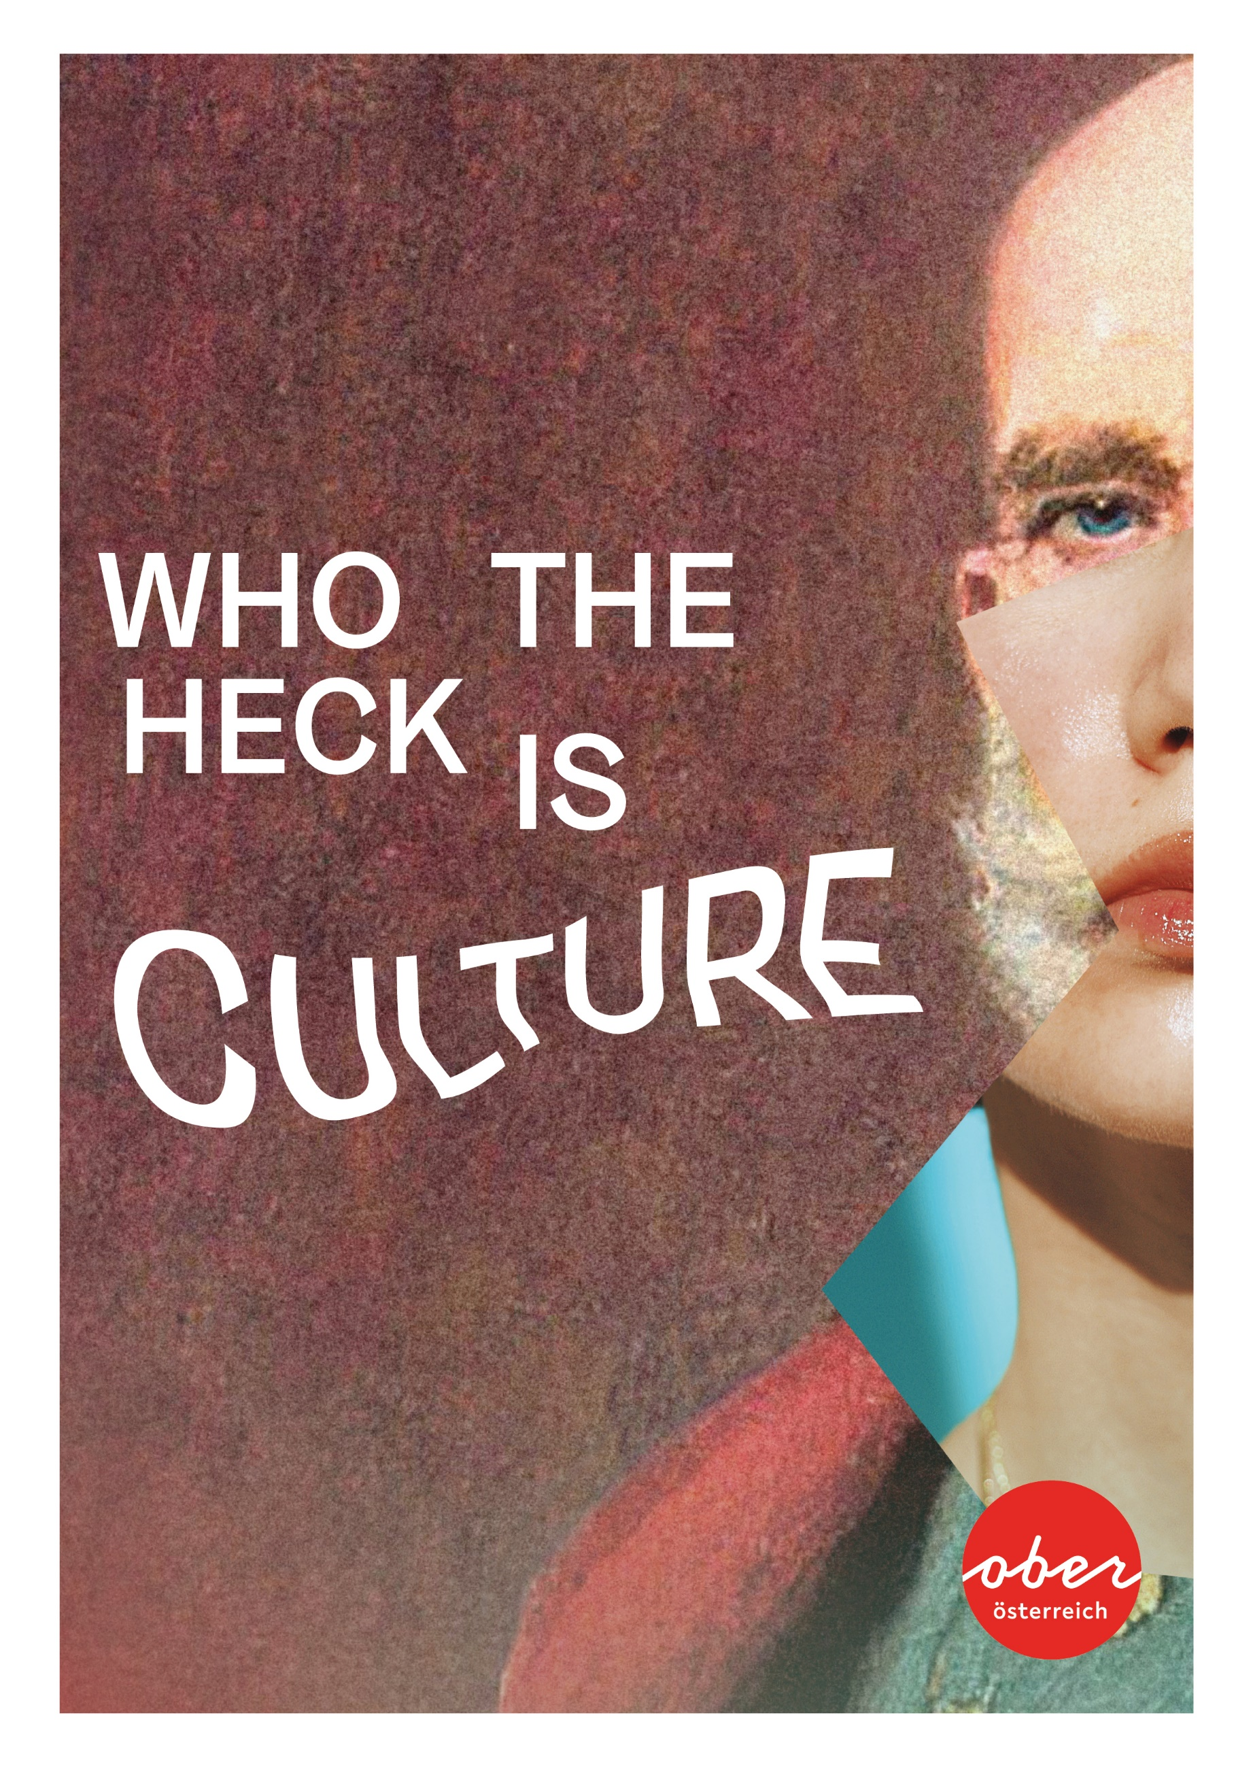

Culture. Who is that?
The 2024 cultural year in Upper Austria. 200 years of Anton Bruckner and Bad Ischl Salzkammergut as the European Capital of Culture.

Upper Austria is the land of 1.5 million cultural ambassadors. They all are culture. And they all make this province so special. They are well-known beyond our borders, like Parov Stelar, the creator of electro swing, singer-songwriters Avec and Ina Regen or star conductor Franz Welser-Möst and world musician Hubert von Goisern. Or the St. Florian Boys’ Choir, young musical ambassadors travelling the world representing Upper Austria. They are active in hundreds and thousands, in one of the 478 music bands in the region, in numerous cultural initiatives and associations. They turn Upper Austria into this wonderful cosmos of culture that is worth experiencing and discovering.

Diverse cultural scene
At the SBÄM Festival in Linz, Austria’s largest pop-punk-rock festival, the new music festival LIDO Sounds in Linz, the “Woodstock of Blasmusik,” Europe’s largest brass music festival and the “INNTöne Jazz Festival,” contemporary music takes centre stage. Cultural ambassadors perform on the stages of the State Theatre and the Music Theatre in Linz, as well as at numerous festivals, from the Lehár Festival in Bad Ischl to the Music Festival in Steyr and the Salzkammergut Festwochen in Gmunden. Many places like Hallstatt and the Danube Limes bear the UNESCO World Heritage label, while the capital city Linz — with the Francisco Carolinum as a centre for media art and the Ars Electronica Center hosting its annual festival in autumn — is a UNESCO City of Media Arts. These elements shape the cultural identity, alongside the rich museum tradition in the region, where, in addition to hotspots like the Lentos Art Museum or the Marmorschlössl in Bad Ischl, it’s quite possible for art enthusiasts to open a museum — as seen with the Museum Angerlehner in Thalheim bei Wels or the Schütz Art Museum in Engelhartszell, the world’s first ZERO ENERGY ART MUSEUM. Experiences of industrial culture, innovative craftsmanship built on traditional knowledge and impressive architectural gems complement Upper Austria’s diverse cultural offerings.

The year 2024 shines with its two cultural beacons far beyond the borders of the region: the 200th birthday of the composer and organ virtuoso Anton Bruckner and the European Capital of Culture, Bad Ischl Salzkammergut 2024. The Bruckner anniversary is a welcome occasion to present Upper Austrian culture in all its diversity, which will be expressed in numerous projects in villages, towns and cities across Upper Austria. In 2024, the Salzkammergut region aims to prove, under the motto “Kultur ist das neue Salz” (Culture is the new salt), that an alpine region with 23 municipalities can come together as a “Cultural Capital Region” for the first time. Furthermore, in 2024, Wolfgangsee Lake celebrates the 1,100th birthday of its patron saint.

Becoming the European Capital of Culture
The programme of the European Capital of Culture, Bad Ischl Salzkammergut 2024, is growing and thriving. It’s a programme fuelled by international impulses that bring new voices and perspectives to the Salzkammergut region. Throughout the year 2024, with some programme elements already in 2023, over 150 projects will be experienced across the Salzkammergut region — a colourful and thought-provoking mixture of regional initiatives and international artists, combining artistic performances and discourse with a sustainable approach, respecting tradition while looking towards the future.

“Culture is the new salt”
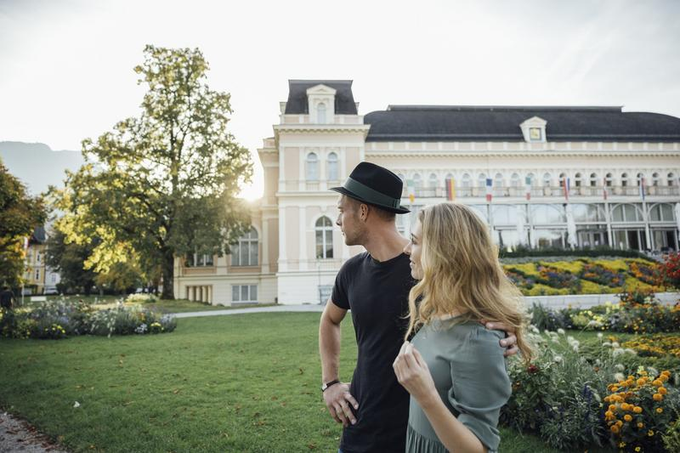
The Salzkammergut region offers a rich tapestry of fascinating stories, places and people set in a breath-taking landscape. Shaped by the elements of salt, water and wood, this region has a multifaceted history. It all began 7,000 years ago in Hallstatt when the story of salt mining started. Salt trade has sustained, enriched and internationally connected the region. It attracted the wealthy and powerful to its lands, and with the concept of “Sommerfrische” (summer retreat), the Salzkammergut became a highly sought-after destination. The historical cultural landscape of the Inner Salzkammergut is now a UNESCO World Heritage Site.

Programme themes
The programme of the European Capital of Culture, Bad Ischl Salzkammergut 2024, is organised around four main themes, each highlighting possibilities for actively shaping our future:
- Power and tradition: Understanding and respecting the dynamics of power and tradition is crucial for comprehending the transformation of local and global identities.
- Culture in flux: Embracing cultural change is fundamental. It allows for innovation, making a region and its society strong and future-oriented.
- Sharing Salzkammergut: This theme, “Sharing Salzkammergut — The Art of Travel,” explores the diverse challenges and opportunities for the high-quality development of tourism.
- Globalocal — Building the New: The aim is to shape rural alpine regions to enable a rural lifestyle while staying connected and engaged globally.

In 2024, the title “European Capital of Culture” is awarded to an inner-alpine, rural region for the first time in history. The town of Bad Ischl, together with 22 other municipalities in Upper Austria and Styria, is creating a cultural region that reinvents itself through the collaboration of art, culture, business and tourism.

Anton Bruckner — the province becomes the stage
Upper Austria, its people and their mentality is characterised by a unique blend of tradition, avant-garde and innovation. This distinctive mixture defines the essence of Upper Austria: tradition and avant-garde coexist harmoniously. It means being aware of the land one inhabits while remaining open to the new and the different. Anton Bruckner serves as a guiding star for this specific balance. Like no other composer of the 19th century, he was deeply rooted in the history and craftsmanship of music.

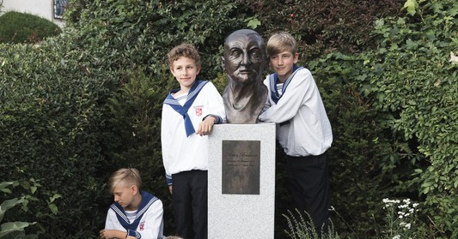
Upper Austria was Anton Bruckner’s homeland. He was born in Ansfelden in 1824 and received his musical upbringing, nurturing and education at the nearby St. Florian Monastery. In Linz, he evolved into a celebrated organ improviser and a composer with a distinctive musical language. Today, his music resounds in the Brucknerhaus Linz, the concert hall named after him. He is the namesake of the Bruckner Orchestra Linz, and his legacy lives on at the Anton Bruckner Private University, where teaching and research continue to thrive.

Wolfgang Year 2024
In the coming year, Wolfgangsee Lake will celebrate the 1,100th anniversary of its patron saint. This birthday will be celebrated grandly, together with the approximately 150 Wolfgang-related locations in Central Europe. The saint, known for his social commitment, is said to have thrown his axe from the mountain into the valley to find a place to build a church, which became the present-day Pilgrimage Church of St. Wolfgang. For centuries, thousands of pilgrims from all directions came to visit St. Wolfgang. Today, the “Wolfgang Paths” are still walked and all lead to the same destination: the hermitage on Falkenstein and the church he built in St. Wolfgang. Numerous events, such as the Art Circle International, where guests can watch artists at work, pilgrimages “In the Footsteps of St. Wolfgang” or the “Wolfgangspiel am See,” a music theatre piece specially written for the 1,100th birthday of St. Wolfgang, are taking place. From 24 May to 22 June 2024, this performance will be presented on a unique mobile stage on the lake. Titled “Wolf — The Mystical,” the play explores the profound questions of human existence and delves into the life of St. Wolfgang.

Press contact: Oberösterreich Tourismus GmbH, Sabine Kner,
Phone: +43 732 7277-552, Mobile: +43 664 32 68 911,
sabine.kner@oberoesterreich.at, www.oberoesterreich.at
Online media service: medienservice.oberoesterreich.at
Selected images: https://arge-digital.canto.global/b/SIRP3

A Colourful Array of Cultural Events

New Year’s concert by the Bruckner Orchestra Linz
The concert on 1 January featuring the Bruckner Orchestra Linz under the baton of their Chief Conductor Markus Poschner at the Brucknerhaus Linz is a cherished tradition. In 2024, it also marks the grand opening of the Bruckner Year, paying tribute to the milestone birthdays of Smetana, Janáček, Schönberg and Ives, all celebrating significant anniversaries.
https://www.brucknerhaus.at/programm/veranstaltungen/neujahrskonzert-2024-01.01.2024-17-002

Opening of the European Capital of Culture, Bad Ischl Salzkammergut, 19 to 21 January 2024
The official commencement of the European Capital of Culture year includes two performances of the operetta “A Woman Who Knows What She Wants!” by Oscar Straus at the Kongresshaus Bad Ischl. On 20 January 2024, approximately 1,000 singers, under the musical leadership of Hubert von Goisern, will “transform the world’s noise into music with yodels and calls” in the Kurpark Bad Ischl. www.salzkammergut-2024.at

“Salt, water, wood & art” — from 20 January 2024
The essential elements of life, salt and water have been enduring factors in the Salzkammergut region throughout history and continue to be so today. The central main exhibition of the Capital of Culture in the Sudhaus in Bad Ischl is dedicated to these themes, showcasing objects, films, photographs and installations. The abundant availability of wood in the Salzkammergut region played a crucial role in the salt production process, so historical contributions related to wood will also complement the themes of salt and water. https://www.salzkammergut-2024.at/projekte/sudhaus/

Gala concert celebrating 50 Years of the Brucknerhaus Linz, 23 March 2024
Exactly 50 years to the day after its inauguration, the Brucknerhaus Linz is commemorating its half-century of existence with a grand gala concert. The apt and monumental “Birthday Serenade” will be performed by the Vienna Philharmonic, conducted by Zubin Mehta, in the form of Anton Bruckner’s Symphony No. 7 in E Major.
www.brucknerhaus.at

Franz Welser-Möst and the Upper Austrian Youth Symphony Orchestra, 31 March to 3 April 2024
One of the great conductors of our time, Franz Welser-Möst, will take the conductor’s stand with the Upper Austrian Youth Symphony Orchestra for four concerts in Ried im Innkreis, Gmunden, Wels and Mauthausen. Just like Anton Bruckner, he too laid his initial musical roots in Upper Austria. www.anton-bruckner-2024.at

Bruckner exhibition at the Anton Bruckner Museum, April to October 2024
The museum at Anton Bruckner’s birthplace in Ansfelden is dedicated to showcasing the life and work of the great composer. In 2024, the house will become the home to numerous Bruckner memorabilia, featuring both well-established loans and a wealth of new exhibits. www.anton-bruckner-2024.at

Crossing Europe Film Festival Linz, 30 April to 5 May 2024
Since 2004, the Crossing Europe Film Festival in Linz has been showcasing high-quality cinema from across the European continent, emphasising contemporary European authorship in film. www.crossingeurope.at

How it all began, May to October 2024
Anton Bruckner spent 13 formative years at the Augustinian St. Florian Monastery. As a choirboy, teacher and organist of the monastery, he embarked on a journey to discover his identity as an artist, which was marked by perseverance and conflicts. An exhibition at the very place where the young son of a village teacher sought his artistic path.
www.anton-bruckner-2024.at

SBÄM Fest in Linz, 31 May to 1 June 2024
This festival rocks! The SBÄM Fest brings together the punk rock scene at Pichlinger Lake in Linz. On 2 June, the US punk rock band NOFX will grace the SBÄM Fest with a concert as part of their grand farewell tour. https://fest.sbam.rocks

Linz AG Bubble Days in Linz on 7 and 8 June 2024
At the unique Linz Harbour Festival, the focus is on trendy and extreme sports, exhilarating wakeboarding action on the Danube and live music by cool local and international acts in a relaxed atmosphere — all with free admission. http://www.bubbledays.at/

“Bruckner’s Salt” on 15 June 2024 in Ebensee
Saltworks are places where salt is extracted, and there’s no better location to savour the crystalline essence of Bruckner’s music. In the spacious production hall of the Ebensee Saline, numerous choirs from Upper Austria, the Bruckner Orchestra Linz and conductor Markus Poschner will come together for a unique, world-class Bruckner event. This extraordinary occasion is presented by the EUROPEAN CAPITAL OF CULTURE BAD ISCHL SALZKAMMERGUT 2024 in collaboration with Anton Bruckner 2024. www.anton-bruckner-2024.at.

European Music & Mobility Day, 21 June 2024
A vibrant street music festival featuring the participation of musicians, regional music schools, music groups, brass bands, choirs and more across the 23 Cultural Capital communities. www.salzkammergut-2024.at

Hausmusik Roas, summer 2024
Since 2021, the Hausmusik Roas project has been meandering through the Salzkammergut region during the summer months. Conceived by Franz Welser-Möst in collaboration with the Salzkammergut Festwochen Gmunden, this initiative revives the age-old tradition of joyful musical gatherings and reinvigorates the practice of domestic music in the region. www.salzkammergut-2024.at

Eisklang, summer 2024
The “Eisklang” concert series offers a unique acoustic experience on selected summer evenings in the Parsifaldom of the Dachstein Giant Ice Cave in Obertraun. Two composition commissions for contemporary music are supported by the European Capital of Culture 2024. www.salzkammergut-2024.at

KirchKlangRaum, summer 2024
This festival places improvisation at its core and features the first international Bruckner Organ Competition in collaboration with Brucknerhaus Linz. The programme includes the finale of the Bruckner Organ Competition with four concerts in Bad Ischl and additional performances throughout the Salzkammergut region. www.salzkammergut-2024.at

Clam Live — concerts in Klam, summer 2024
Clam Castle is one of Austria’s most extraordinary event venues, hosting numerous concerts with international musicians and bands each summer. https://clamlive.at

The Woodstock of Brass Music in Innviertel, 27 to 30 June
The largest brass festival in Europe draws 85,000 music enthusiasts to Innviertel. Swing, jazz, funk, ska, reggae or electronic music — there’s a place for everything here. From early morning to late night, music fills the air, turning every corner into a stage and every person into a performer. A unique highlight is the “Upper Austria Collective Play,” where 19,000 musicians come together to make music.
https://www.woodstockderblasmusik.at/

Klassik am Dom Linz, July / August 2024
This concert series takes place against the breath-taking backdrop of the New Cathedral in Linz. In 2023, it featured renowned artists like Norah Jones, Plácido Domingo, Eros Ramazzotti and David Garrett. www.klassikamdom.at.

Lehár Festival Bad Ischl, July / August 2024
Austria’s largest operetta festival in Bad Ischl, located in the Salzkammergut region, thrilled audiences in 2023 with productions of Leo Fall’s “Madame Pompadour,” the classic “Der Vogelhändler” by Carl Zeller and “Schön ist die Welt” by Franz Lehár. www.leharfestival.at

36th International Pflasterspektakel Linz, 18 to 20 July 2024
For three days, the streets of Linz’s city centre become a stage for street art from around the world. It’s a captivating spectacle featuring music, performance, comedy and theatre at every street corner and in the courtyards of Linz. www.pflasterspektakel.at

Inntöne — music on the farm in July 2024
The legendary jazz festival held on a farm in the Innviertel region — Paul Zauner, an internationally renowned jazz trombonist from Upper Austria, gathers jazz world luminaries in the unique setting of his farm in Diersbach. www.inntoene.at

101st Mondsee Jedermann in July and August 2024
Presented in the local vernacular by Franz Löser and approved by Hugo von Hofmannsthal, the “Mondsee Jedermann” has been performed in Mondsee since 1922. The performance takes place on the open-air stage in the Karlsgarten in Mondsee, where there is also a freely accessible exhibition on the history of the performance. https://mondsee.salzkammergut.at

Donaufestwochen in Strudengau, July and August 2024
The Strudengau region along the Danube annually serves as a stage for a vibrant dialogue between early music and modern compositions, unveiling numerous musical gems. https://www.donau-festwochen.at/

St. Florian Bruckner Days, 14 to 24 August 2024
A “sonorous” project that began in 1997 as a private initiative and is now, according to the London-based “The Bruckner Journal”, a highlight among global Bruckner events. This small yet exquisite Bruckner festival takes place at one of the composer’s most important locations, the Augustinian St. Florian Monastery. Each year, it explores a selected Bruckner work and focuses on Anton Bruckner’s 9th Symphony at the heart of the festival. www.brucknertage.at

Imperial Days in Bad Ischl, 9 to 18 August 2024
Around 18 August, Bad Ischl celebrates the birthday of Emperor Franz Joseph I. Key events include the arrival of the Emperor’s train at the station, the Emperor’s festival in the Kurpark on 15 August and the Imperial Mass on 18 August.
https://badischl.salzkammergut.at

International Bruckner Festival, 4 September to 11 October 2024
Highlights of the International Bruckner Festival 2024 include concerts by the Cleveland Orchestra under Franz Welser-Möst on Bruckner’s birthday in Ansfelden (4 September) and the Vienna Philharmonic under Christian Thielemann (19 September) at the Brucknerhaus. Additionally, all eleven Bruckner symphonies will be performed in their original sound as part of a cycle — an experience unique to the Bruckner City of Linz. www.brucknerhaus.at

Ars Electronica Festival Linz, early September 2024
This international festival for art, technology and society transforms Linz into the epicentre of media art for five days. Addressing topics such as new technologies, artificial intelligence and biotech, Ars Electronica explores current developments and their impact on society. https://ars.electronica.art/festival

4th Long Night of Industrial Culture, early September 2024
Renowned companies in the Traunsee-Almtal region, including Gmundner Keramik, Stern & Hafferl, Traunsee Schifffahrt, Grüne Erde, the Austrian Museum of Papermaking in Steyrermühl, the Kammerhof Museum Gmunden and the Scythe Museum Geyerhammer in Scharnstein, offer glimpses behind the scenes during this event. www.industriekultur.at

New Salt Festival, 18 to 22 September 2024
The New Salt Festival explores electronic music and contemporary composition with a focus on cross-genre and multimedia projects. These projects culminate in a multi-day festival in Bad Ischl and the Salzkammergut region in autumn 2024. www.salzkammergut-2024.at

Birthday Concert for Anton Bruckner, 19 September 2024
The Vienna Philharmonic, conducted by Christian Thielemann, will perform at the Brucknerhaus Linz, featuring Felix Mendelssohn Bartholdy’s 3rd Symphony and Anton Bruckner’s 1st Symphony.
www.anton-bruckner-2024.at

Bruckner Forever!, September 2024 to February 2025
This exhibition at the Nordico Stadtmuseum Linz explores Anton Bruckner, not just as a local figure in Upper Austria but as a globally recognised and esteemed musician. The exhibition commemorates the man to whom an entire year in Linz and Upper Austria has been dedicated, marking 200 years since his birth. www.anton-bruckner-2024.at

Komm, sing mit!, October 2024 to January 2025
Anton Bruckner and choral music are closely intertwined. The Lentos Kunstmuseum Linz explores this aspect of Bruckner’s work from the perspective of contemporary art. www.anton-bruckner-2024.at

Salzkammergut Festwochen Gmunden
Covering theatre, music, readings and visual arts, the Salzkammergut Festwochen Gmunden’s programme encompasses all facets of art and culture and now extends throughout the year. The current programme is available under www.festwochen-gmunden.at

International Summer of Music Bad Schallerbach
A festival of timeless and elegant culture, running for 10 months with 300 artists. Artistic director Peter Gillmayr invites you to the renowned International Summer of Music Bad Schallerbach for the 30th time. https://www.musiksommerbadschallerbach.at/

Being Anton, throughout 2024
Immerse yourself twice in the world of Anton Bruckner at the Ars Electronica Center Linz. First, explore the musical world of Anton Bruckner and the Bruckner Orchestra Linz, then delve into the thoughts of Anton Bruckner. Two exhibition installations at the Ars Electronica Center Linz, developed by the Ars Electronica Futurelab.
www.anton-bruckner-2024.at

For all cultural events in Upper Austria, visit www.kultururlaub.at, images: https://arge-digital.canto.global/b/SIRP3

