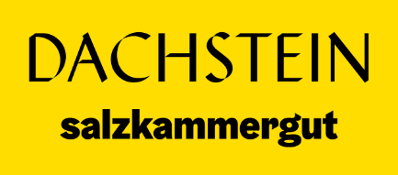
Mountainbiken in the Inner Salzkammergut
An adventure in the middle of nature

The Inner Salzkammergut, with its picturesque lakes, majestic mountains and dense forests has long made a name for itself as a paradise for outdoor enthusiasts. Up to 5,000 starters travel every year to the Holiday Region Dachstein Salzkammergut for the Salzkammergut Mountain Bike Trophy race.
But not only during the Trophy, mountain biking is becoming increasingly popular in the region. Since this year, the region also offers challenging trails for experienced riders and, of course, relaxed routes for beginners who want to experience the beauty of nature on two wheels.

Variety of trails: make 800 out of 200
One of the great attractions for mountain bikers in the Inner Salzkammergut is the variety of routes. From gentle trails along the lakes to challenging climbs in the mountains, there is something for every taste and ability. Mountain bikers can experience nature in its full glory and at the same time put their physical abilities to the test. The Dachstein Salzkammergut, together with the Austrian Federal Forests, provides around 200 kilometres of forest roads for mountain biking, with clever route guidance, this results in an exorbitant 800-kilometre network of routes through the UNESCO World Heritage region of Hallstatt/Dachstein-Salzkammergut.

Explore the lake region around the Dachstein Salzkammergut
For those who prefer a more relaxed ride: from the Dachstein Salzkammergut you can easy reach the glittering lakes of the Salzkammergut. Popular destinations for leisurely excursions where you can enjoy the idyllic surroundings on your bike. Also, numerous cafés and restaurants along the trails invite you to enjoy the famous Salzkammergut culinary.

Adventure in the mountains in the heart of Austria
For adventurous mountain bikers, there are plenty of trails to challenge you in the mountains of the Inner Salzkammergut. From steep climbs to technically challenging descents, the region offers everything a mountain biker's heart desires. With the right equipment in the form of a top-equipped e-mountain bike and an experienced guide, you can enjoy unforgettable experiences in the Alps and on the mountain pastures in the Dachstein Salzkammergut.

Enjoying nature, respecting nature
When mountain biking in the Inner Salzkammergut, it is important to respect nature and act responsibly. The area is a nature reserve of inestimable value, and it is importants to leave no trace and use the 800 km of designated mountain bike trails in harmony with nature.

Plan your trip to the World Heritage Site
The Inner Salzkammergut offers great opportunities for mountain bikers, eBikers and gravel bikers throughout the entire bike season from April to October. Whether alone, with friends or family, the region has something to offer for everyone. A region that offers incomparable nature experiences and exciting challenges.

